**Cloud Computing**

**M.Tech. Seminar Report**   
by

**Abhirup Ghosh**   
**(Roll no :09305052)**

*under the guidance of*   
**Prof. Anirudha Sahoo**



Department of Computer Science and Engineering Indian Institute of Technology, Bombay   
Powai, Mumbai 400076.

**Cloud Computing**

**Abstract**

The term “cloud computing” is a recent buzzword in the IT world. Behind this fancy poetic phrase there lies a true picture of the future of computing for both in technical perspective and social perspective. Though the term “Cloud Computing” is recent but the idea of centralizing computation and storage in distributed data centers maintained by third party companies is not new but it came in way back in 1990s along with distributed computing approaches like grid computing. Cloud computing is aimed at providing IT as a service to the cloud users on-demand basis with greater flexibility, availability, reliability and scalability with utility computing model. This new paradigm of computing has an immense potential in it to be used in the field of e-governance and in rural development perspective in developing countries like India.

1

**Cloud Computing**

**Acknowledgment**

I am greatly indebted to my guide **Prof. Anirudha Sahoo** for his invaluable

guidance during the course of the seminar. He always gave useful suggestions and

also helped me when the work was not moving ahead at times.

*Abhirup Ghosh*

IIT Bombay

2

**Cloud Computing**

**Contents**

|  |  |  |  |  |  |
| --- | --- | --- | --- | --- | --- |
| **1** | **Introduction** | | | | **4** |
| **2** | **Cloud Computing Basics** | | | | **5** |
| **3** | 2.1 | Types of Cloud . . . . . . . . . . . . . . . . . . . . . . . . . . . . . . | | | 6 |
| 2.2 | Cloud Stakeholders . . . . . . . . . . . . . . . . . . . . . . . . . . . . | | | 6 |
| 2.3 | Advantages of using Cloud . . . . . . . . . . . . . . . . . . . . . . . . | | | 7 |
| **Motivation towards Cloud in recent time** | | | | **7** |
| **4** | **Cloud Architecture** | | | | **8** |
| **5** | 4.1 | Comparison between Cloud Computing and Grid Computing . . . . . | | | 10 |
| 4.2 | Relation between Cloud Computing and Utility Computing . . . . . . | | | 10 |
| 4.3 | Types of utility cloud services . . . . . . . . . . . . . . . . . . . . . . | | | 10 |
| **Popular Cloud Applications: A Case study** | | | | **13** |
| **6** | 5.1 | Amazon EC2 and S3 Services | | . . . . . . . . . . . . . . . . . . . . . . | 13 |
| 5.2 | Google App-Engine . . . . . . . . . . . . . . . . . . . . . . . . . . . . | | | 15 |
| 5.3 | Windows Azure | . . . . . . . . . . . . . . . . . . . . . . . . . . . . . | | 16 |
| **Cloud Computing Application in Indian context** | | | | **19** |
| **7** | 6.1 | E-Governance . . . . . . . . . . . . . . . . . . . . . . . . . . . . . . . | | | 19 |
| 6.2 | Rural development . . . . . . . . . . . . . . . . . . . . . . . . . . . . | | | 22 |
| **Conclusion** | | | | **25** |

3

**Cloud Computing**

|  |  |
| --- | --- |
| **1** | **Introduction** |

Cloud computing is a recently developing paradigm of distributed computing. Though it is not a new idea that emerged just recently. In 1969 [16] L. Kleinrock anticipated,“As of now, computer networks are still in their infancy. But as they grow up and become more sophisticated, we will probably see the spread of ’computer utilities’which, like present electric and telephone utilities, will service individual homes and offices across the country.” His vision was the true indication of today’s utility based computing paradigm. One of the giant steps towards this world was taken in mid 1990s when grid computing was first coined to allow consumers to obtain computing power on demand. The origin of cloud computing can be seen as an evolution of grid computing technologies. The term Cloud computing was given prominence first by Google’s CEO Eric Schmidt in late 2006 (may be he coined the term) [6]. So the birth of cloud computing is very recent phenomena although its root belongs to some old ideas with new business, technical and social perspectives. From the archi-tectural point of view cloud is naturally build on an existing grid based architecture and uses the grid services and adds some technologies like virtualization and some business models.

In brief cloud is essentially a bunch of commodity computers networked to-gether in same or different geographical locations, operating together to serve a number of customers with different need and workload on demand basis with the help of virtualization. Cloud services are provided to the cloud users as utility ser-vices like water, electricity, telephone using pay-as-you-use business model. These utility services are generally described as XaaS (X as a Service) where X can be Software or Platform or Infrastructure etc. Cloud users use these services provided by the cloud providers and build their applications in the internet and thus deliver them to their end users. So the cloud users don’t have to worry about installing, maintaining hardware and software needed. And they also can afford these services as they have to pay as much they use. So the cloud users can reduce their expen-diture and effort in the field of IT using cloud services instead of establishing IT infrastructure themselves.

Cloud is essentially provided by large distributed data centers. These data centers are often organized as grid and the cloud is built on top of the grid services. Cloud users are provided with virtual images of the physical machines in the data centers. This virtualization is one of the key concept of cloud computing as it essentially builds the abstraction over the physical system. Many cloud applications are gaining popularity day by day for their availability, reliability, scalability and utility model. These applications made distributed computing easy as the critical

4

**Cloud Computing**

aspects are handled by the cloud provider itself.

Cloud computing is growing now-a-days in the interest of technical and busi-ness organizations but this can also be beneficial for solving social issues. In the recent time E-Governance is being implemented in developing countries to improve efficiency and effectiveness of governance. This approach can be improved much by using cloud computing instead of traditional ICT. In India, economy is agriculture based and most of the citizens live in rural areas. The standard of living, agricul-tural productivity etc can be enhanced by utilizing cloud computing in a proper way. Both of these applications of cloud computing have technological as well as social challenges to overcome.

In this report we would try to clarify some of the ideas – Why is cloud computing a buzzword today? i.e. what are the benefits the provider and the users get using cloud? Though its idea has come long back in 1990 but what situation made it indispensable today? How is cloud built? What differentiates it from similar terms like grid computing and utility computing? What are the different services are provided by the cloud providers? Though cloud computing now-a-days talks about business enterprises not the non-profit organizations; how can this new paradigm be used in the services like e-governance and in social development issues of rural India?

**2**  **Cloud Computing Basics**

Cloud computing is a paradigm of distributed computing to provide the customers on-demand, utility based computing services. Cloud users can provide more reli-able, available and updated services to their clients in turn. Cloud itself consists of physical machines in the data centers of cloud providers. Virtualization is pro-vided on top of these physical machines. These virtual machines are provided to the cloud users. Different cloud provider provides cloud services of different abstraction level. E.g. Amazon EC2 enables the users to handle very low level details where Google App-Engine provides a development platform for the developers to develop their applications. So the cloud services are divided into many types like Software as a Service, Platform as a Service or Infrastructure as a Service. These services are available over the Internet in the whole world where the cloud acts as the single point of access for serving all customers. Cloud computing architecture addresses difficulties of large scale data processing.

5

**Cloud Computing**

|  |  |
| --- | --- |
| **2.1** | **Types of Cloud** |

Cloud can be of three types [20].

1. Private Cloud – This type of cloud is maintained within an organization and used solely for their internal purpose. So the utility model is not a big term in this scenario. Many companies are moving towards this setting and experts consider this is the 1st step for an organization to move into cloud. Security, network bandwidth are not critical issues for private cloud.

2. Public Cloud – In this type an organization rents cloud services from cloud providers on-demand basis. Services provided to the users using utility com-puting model.

3. Hybrid Cloud – This type of cloud is composed of multiple internal or exter-nal cloud. This is the scenario when an organization moves to public cloud computing domain from its internal private cloud.

**2.2**  **Cloud Stakeholders**

To know why cloud computing is used let’s first concentrate on who use it. And then we would discuss what advantages they get using cloud. There are three types of stakeholders cloud providers, cloud users and the end users [Figure 1]. Cloud providers provide cloud services to the cloud users. These cloud services are of the form of utility computing i.e. the cloud users uses these services pay-as-you-go model. The cloud users develop their product using these services and deliver the product to the end users.

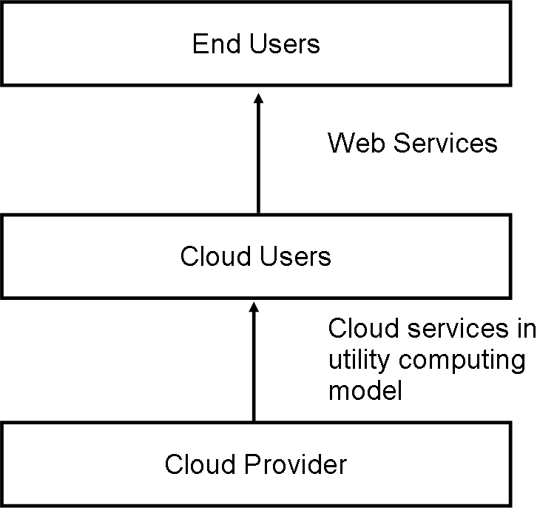

Figure 1: Interconnection between cloud stakeholders

6

**Cloud Computing**

|  |  |
| --- | --- |
| **2.3** | **Advantages of using Cloud** |

The advantages for using cloud services can be of technical, architectural, business etc [5, 6].

1. Cloud Providers’ point of view

(a) Most of the data centers today are under utilized. They are mostly 15% utilized. These data centers need spare capacity just to cope with the huge spikes that sometimes get in the server usage. Large companies having those data centers can easily rent those computing power to other organizations and get profit out of it and also make the resources needed for running data center (like power) utilized properly.

(b) Companies having large data centers have already deployed the resources and to provide cloud services they would need very little investment and the cost would be incremental.

2. Cloud Users’ point of view

(a) Cloud users need not to take care about the hardware and software they use and also they don’t have to be worried about maintenance. The users are no longer tied to some one traditional system.

(b) Virtualization technology gives the illusion to the users that they are having all the resources available.

(c) Cloud users can use the resources on demand basis and pay as much as they use. So the users can plan well for reducing their usage to minimize their expenditure.

(d) Scalability is one of the major advantages to cloud users. Scalability is provided dynamically to the users. Users get as much resources as they need. Thus this model perfectly fits in the management of rare spikes in the demand.

**3**  **Motivation towards Cloud in recent time**

Cloud computing is not a new idea but it is an evolution of some old paradigm of distributed computing. The advent of the enthusiasm about cloud computing in recent past is due to some recent technology trend and business models [5].

7

**Cloud Computing**

1. High demand of interactive applications – Applications with real time response and with capability of providing information either by other users or by non-human sensors gaining more and more popularity today. These are generally attracted to cloud not only because of high availability but also because these services are generally data intensive and require analyzing data across different sources.

2. Parallel batch processing – Cloud inherently supports batch-processing and analyzing tera-bytes of data very efficiently. Programming models like Google’s map-reduce [18] and Yahoo!’s open source counter part Hadoop can be used to do these hiding operational complexity of parallel processing of hundreds of cloud computing servers.

3. New trend in business world and scientific community – In recent times the business enterprises are interested in discovering customers needs, buying pat-terns, supply chains to take top management decisions. These require analysis of very large amount of online data. This can be done with the help of cloud very easily. Yahoo! Homepage is a very good example of such thing. In the homepage they show the hottest news in the country. And according to the users’ interest they change the ads and other sections in the page. Other than these many scientific experiments need very time consuming data processing jobs like LHC (Large Hadron Collider). Those can be done by cloud.

4. Extensive desktop application – Some desktop applications like Matlab, Math-ematica are becoming so compute intensive that a single desktop machine is no longer enough to run them. So they are developed to be capable of using cloud computing to perform extensive evaluations.

**4**  **Cloud Architecture**

The cloud providers actually have the physical data centers to provide virtualized services to their users through Internet. The cloud providers often provide separa-tion between application and data. This scenario is shown in the Figure 2. The underlying physical machines are generally organized in grids and they are usu-ally geographically distributed. Virtualization plays an important role in the cloud scenario. The data center hosts provide the physical hardware on which virtual ma-chines resides. User potentially can use any OS supported by the virtual machines used.

8

**Cloud Computing**

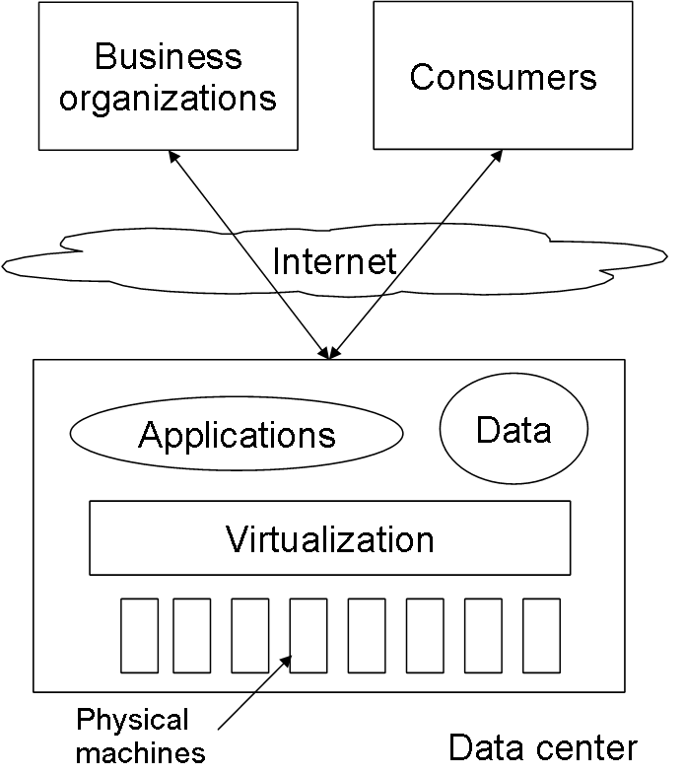

Figure 2: Basic Cloud Computing Architecture

Operating systems are designed for specific hardware and software. It results in the lack of portability of operating system and software from one machine to another machine which uses different instruction set architecture. The concept of virtual machine solves this problem by acting as an interface between the hardware and the operating system called as system VMs [21]. Another category of virtual machine is called process virtual machine which acts as an abstract layer between the operating system and applications. Virtualization can be very roughly said to be as software translating the hardware instructions generated by conventional soft-ware to the understandable format for the physical hardware. Virtualization also includes the mapping of virtual resources like registers and memory to real hard-ware resources. The underlying platform in virtualization is generally referred to as host and the software that runs in the VM environment is called as the guest. The Figure 3 shows very basics of virtualization. Here the virtualization layer cov-ers the physical hardware. Operating System accesses physical hardware through virtualization layer. Applications can issue instruction by using OS interface as well as directly using virtualizing layer interface. This design enables the users to use applications not compatible with the operating system.

Virtualization enables the migration of the virtual image from one physical machine to another and this feature is useful for cloud as by data locality lots of optimization is possible and also this feature is helpful for taking back up in different locations. This feature also enables the provider to shut down some of the data center physical machines to reduce power consumption.

9

**Cloud Computing**

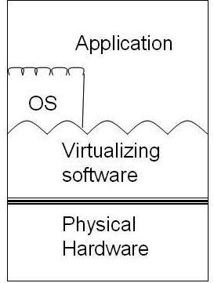

Figure 3: Virtualization basic [21]

**4.1**  **Comparison between Cloud Computing and Grid Com-**

**puting**

Most of the cloud architectures are built on Grid architecture and utilizes its ser-vice. Grid is also a form of distributed computing architecture where organizations owning data centers collaborate with each other to have mutual benefit. Although if apparently seen it seems that cloud computing is no different from its originator in the first look but there are substantial difference between them in spite of so many similarities [12]. The relation between Grid and cloud computing is discussed in Table 1.

**4.2**  **Relation between Cloud Computing and Utility Com-** **puting**

The cloud users enjoy utility computing model for interacting with cloud service providers. This Utility computing is essentially not same as cloud computing. Utility computing is the aggregation of computing resources, such as computation and storage, as a metered service similar to a traditional public utility like electricity, water or telephone network. This service might be provided by a dedicated computer cluster specifically built for the purpose of being rented out, or even an under-utilized supercomputer. And cloud is one of such option of providing utility computing to the users.

**4.3**  **Types of utility cloud services**

Utility computing services provided by the cloud provider can be classified by the type of the services. These services are typically represented as XaaS where we

10

**Cloud Computing**

Table 1: Comparison between Grid & Cloud computing

|  |  |  |
| --- | --- | --- |
| Characteristics | Grid Computing | Cloud Computing |

|  |  |  |
| --- | --- | --- |
| Business Model | Adopts project oriented busi-ness model. The participating parties agree to share a cer-tain amount of resource with others and gain the opportu-nity of using all other grids’resources. | Uses Pay-as-you-go model. |
| Resource Management | Schedules dedicated resources by a queuing service. Un-til all the resources are avail-able as specified by the LRM (Local Resource Manager) the job waits in the queue. Thus interactive and latency inten-sive applications are not exe-cuted efficiently in grid. | Share all resources simultane-ously to all the users at the same time. This allows la-tency intensive and interac-tive applications run naively in cloud. |
| Virtualization | No virtualization, as the data centers are handled by the in-dividual organizations of their own. So they generally man-age those usually physically but not by virtualization. Al-though there are some efforts being given by some com-panies like Nimbus for vir-tualization to make dynamic deployment and abstraction available. | For cloud computing one of the essential components is virtualization. This is for pro-viding abstraction and encap-sulation to the users of the cloud. |
| Application model | Executing tasks may be small or large, loosely coupled or tightly coupled, compute in-tensive or data intensive. | |  |  |  |  | | --- | --- | --- | --- | | Supports | only | loosely | cou- |   pled and transaction oriented, mostly interactive jobs. |
| Security model | Grids build on the assump-tion that resources are hetero-geneous and dynamic. Thus security is engineered in fun-damental grid infrastructure. | Cloud security is now in its in-fancy. |

11

**Cloud Computing**

can replace X by Infrastructure or Platform or Hardware or Software or Desktop or Data etc. There are three main types of services most widely accepted - Software as a Service, Platform as a Service and Infrastructure as a Service. These services provide different levels of abstraction and flexibility to the cloud users. This is shown in the Figure 4.

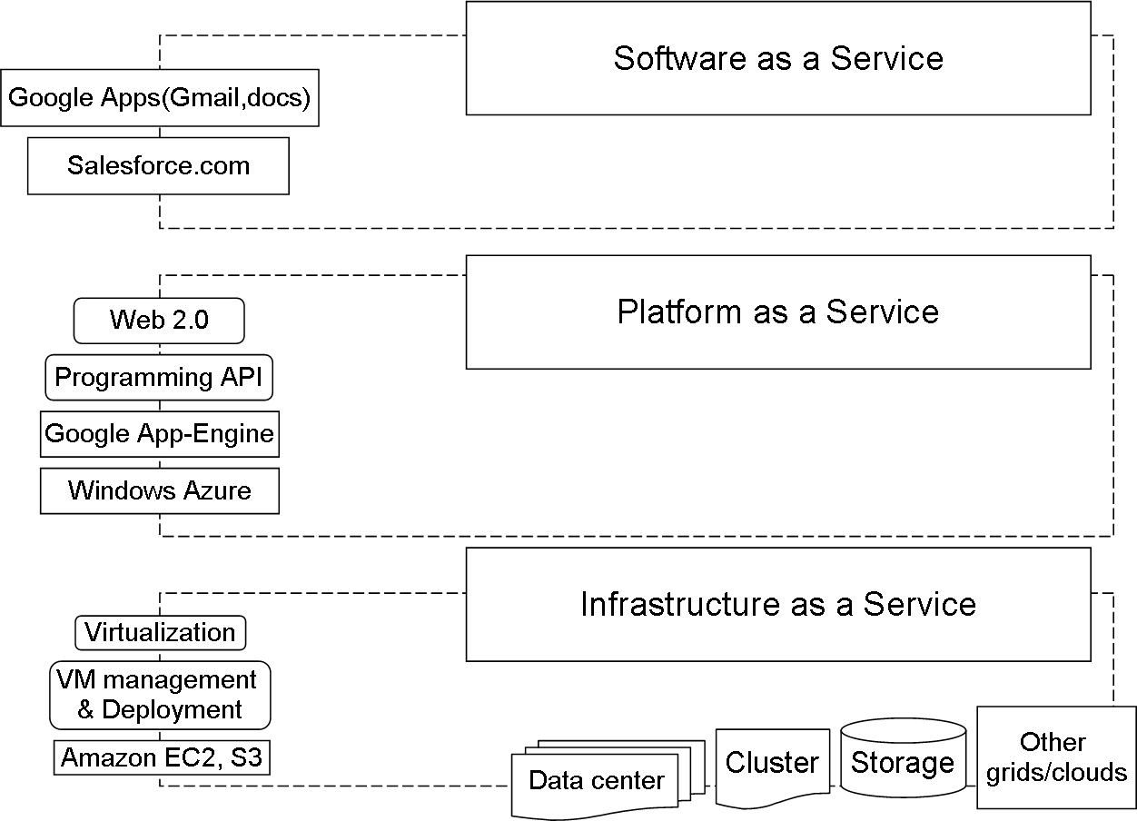

Figure 4: Cloud Service stack

We’ll now discuss some salient features of some of these models -

1. SaaS (Software as a service) – Delivers a single application through the web browser to thousands of customers using a multitenant architecture. On the customer side, it means no upfront investment in servers or software licens-ing; on the provider side, with just one application to maintain, cost is low compared to conventional hosting. Under SaaS, the software publisher (seller) runs and maintains all necessary hardware and software. The customer of SaaS accesses the applications through Internet. For example Salesforce.com with yearly revenues of over $300M, offers on-demand Customer Relationship Management software solutions. This application runs on Salesforce.com’s own infrastructure and delivered directly to the users over the Internet. Salesforce

12

**Cloud Computing**

does not sell perpetual licenses but it charges a monthly subscription fee start-ing at $65/user/month [10]. Google docs is also a very nice example of SaaS where the users can create, edit, delete and share their documents, spread-sheets or presentations whereas Google have the responsibility to maintain the software and hardware.

E.g. - Google Apps, Zoho Office.

2. PaaS (Platform as a service) – Delivers development environment as a ser-vice. One can build his/her own applications that run on the provider’s infras-tructure that support transactions, uniform authentication, robust scalability and availability. The applications built using PaaS are offered as SaaS and consumed directly from the end users’ web browsers. This gives the ability to integrate or consume third-party web-services from other service platforms.

E.g. - Google App Engine.

3. IaaS (Infrastructure as a Service) – IaaS service provides the users of the cloud greater flexibility to lower level than other services. It gives even CPU clocks with OS level control to the developers.

E.g. - Amazon EC2 and S3.

**5**  **Popular Cloud Applications: A Case study**

Applications using cloud computing are gaining popularity day by day for their high availability, reliability and utility service model. Today many cloud providers are in the IT market. Of those Google App-Engine, Windows Azure and Amazon EC2, S3 are prominent ones for their popularity and technical perspective.

**5.1**  **Amazon EC2 and S3 Services**

Amazon Elastic Computing (EC2) [13] is one of the biggest organizations to pro-vide *Infrastructure as a Service*. They provide the computer architecture with XEN virtual machine. Amazon EC2 is one of the biggest deployment of XEN architec-ture to date. The clients can install their suitable operating system on the virtual

|  |  |  |
| --- | --- | --- |
| machine. | EC2 uses Simple Storage Service (S3) for storage of data. | Users can |

hire suitable amount CPU power, storage, and memory without any upfront com-mitment. Users can control the entire software stack from kernel upwards. The

13

**Cloud Computing**

architecture has two components one is the EC2 for computing purposes and S3 is for storage purposes [14].

*•* Simple Storage Service: S3 can be thought as a globally available distributed hash table with high-level access control. Data is stored in name/value pairs. Names are like UNIX file names and the value can be object having size up-to 5 GB with up-to 4K of metadata for each object. All objects in Amazon’s S3 must fit into the global namespace. This namespace consists of a “bucket name” and an “object name”. Bucket names are like user names in traditional email account and provided by Amazon on first come first serve basis. An AWS (Amazon Web Services) account can have maximum of 100 buckets.

Data to S3 can be sent by SOAP based API or with raw HTTP “PUT” com-mands. Data can be retrieved using SOAP HTTP or BitTorrent. While using BitTorrent the S3 system operates as both tracker and the initial seeder. There are also some tools available which enables the users to view S3 as a remote file system. Upload download rate from and to S3 is not that much exiting. One developer from Germany reported experiencing 10-100 KBps. This rate can go up-to 1-2 MBps on the higher side depending on the time of the day. Although the speed is not that much fascinating it is good enough for deliv-ering web objects and for backup purposes although for doing computation it is not suitable.

Amazon S3 has a very impressive support for privacy, integrity and short term availability. Long term availability is unknown as this depends on the internal commitment of Amazon data centers. Data privacy can be obtained by encrypting the data to be stored. But this encryption is to be done by the user before storing the data in S3. One can use SSL with HTTPS to connect to S3 for more security but this usage of SSL increases upload/download time also. Data integrity can be achieved by checking end to end MD5 checking. When an object is stored into S3 then it returns MD5 of that object. One can easily check it with previously computed hash value to guarantee data integrity. Short term availability depends upon the Amazon’s connectivity and load on its server at that instant. Once the data is actually in the S3 then it is Amazon’s responsibility to take care of it’s availability. They claim that the data is backed up on multiple hard drives in multiple data centers but doesn’t guarantee this by any Service Level Agreement. There is no backup or recovery mechanism if the user accidentally deletes any data.

Amazon has a very impressive scheme of authentication in comparison to other cloud services. Every AWS account has an Access Key ID and a Secret Key.

14

**Cloud Computing**

The ID is of 20 characters and the Key is a 41 character string. When signing HMAC is first computed for the sign request parameters using that Key. And in the Amazon server that HMAC is again computed and compared with the value previously computed in the client side. These requests also include timestamp to prevent replay attacks.

*•* Elastic Compute Cloud: As the name implies EC2 rents cloud of computers to the users with flexibility of choosing the configuration of the virtual machine like RAM size, local disk size, processor speeds etc.

Machines that deliver EC2 services are actually virtual machines running on top of XEN platform. Users can store a disk image inside S3 and create a virtual machine in EC2 using tools provided by Amazon. This virtual machine can be easily instantiated using a java program and can also be monitored. As EC2 is based on XEN it supports any linux distribution as well as other OSs. Amazon does not promise about reliability of the EC2 computers. Any machine can crash at any moment and they are not backed up. Although these machine generally don’t crash according to the experience of the users but it is safe to use S3 to store information which is more reliable and replicated service. EC2 security model is similar to that of S3. The only difference is that the commands are signed with an X 509 private key. But this key is downloaded from AWS account so the security depends fundamentally on the AWS username and password.

**5.2**  **Google App-Engine**

Google App-Engine [1] is a platform for developing and deploying web applications in Google’s architecture. This provides *Platform as a Service* to the cloud users. In 2008 Google App-Engine was first released as beta version. Languages supported by Google App-Engine are python, java and any extension of JVM languages. App-Engine requires developers to use only languages which are supported by it and this is also applied with APIs and frameworks. Now Google App-Engine allows storing and retrieving data from a BigTable non-relational database.

AppEngine applications are expected to be request-reply based. Google App-engine provides automatic scalability, persistent data storage service. Data store features a query engine and transaction capabilities. These applications are easy to scale as traffic and data storage need to grow so the cloud user doesn’t have to worry about the spikes in the traffic or data. These applications are generally suitable for social networking start-ups, event-based websites catering to seasonal

15

**Cloud Computing**

events or institutions (schools, colleges, universities, government agencies) etc [22].

**5.3**  **Windows Azure**

Windows Azure [9] is an intermediate in the spectrum of flexibility vs programmer convenience. These systems use .NET libraries to facilitate language independent managed environment. This service falls under the category of *Platform as a Ser-vice*. Though it is actually in between complete application framework like Google App-Engine and hardware virtual machines like EC2. Azure applications run on machines in Microsoft data centers. By using this service customers can use it to run applications and store data on internet accessible machines owned by Microsoft. windows Azure platform provides three fundamental components - compute com-ponent, storage component and fabric component. Basic components of Windows Azure are shown in Figure 5.

*•* The Compute Service: The primary goal of this platform is to support a large number of simultaneous users. (Microsoft also said that they would use Azure to build their SaaS applications which motivated many potential users.) To allow applications to scale out Microsoft uses multiple instances of that appli-cations on virtual machines provided by Hypervisor. Developers use Windows Azure portal through Web browser, and use Windows live ID to sign in into his/her hosting account or storage account or both.

Two different types of Azure instance is available: Web role instance and Worker role instances.

**–** Web role instance: As the name implies this type of instance can accept HTTP or HTTPS requests. For this facility Microsoft uses IIS (Internet Information Services) as a web server inside the VM provided. Developers can build applications using ASP.NET, Windows Communication Foun-dation (WCF) or any other .NET technology or native codes also like C++. PHP or java based technologies also supported in Azure. Azure scales applications by running multiple instances without any affinity with a particular Web role instance. So it is perfectly natural for an Azure application to serve multiple requests from a single user by multiple in-stances. So this requires to write the client state in the Azure storage after each client request.

**–** Worker role instance: This type of instances are very similar to that of Web role instances. But unlike the Web role instances these don’t have

16

**Cloud Computing**

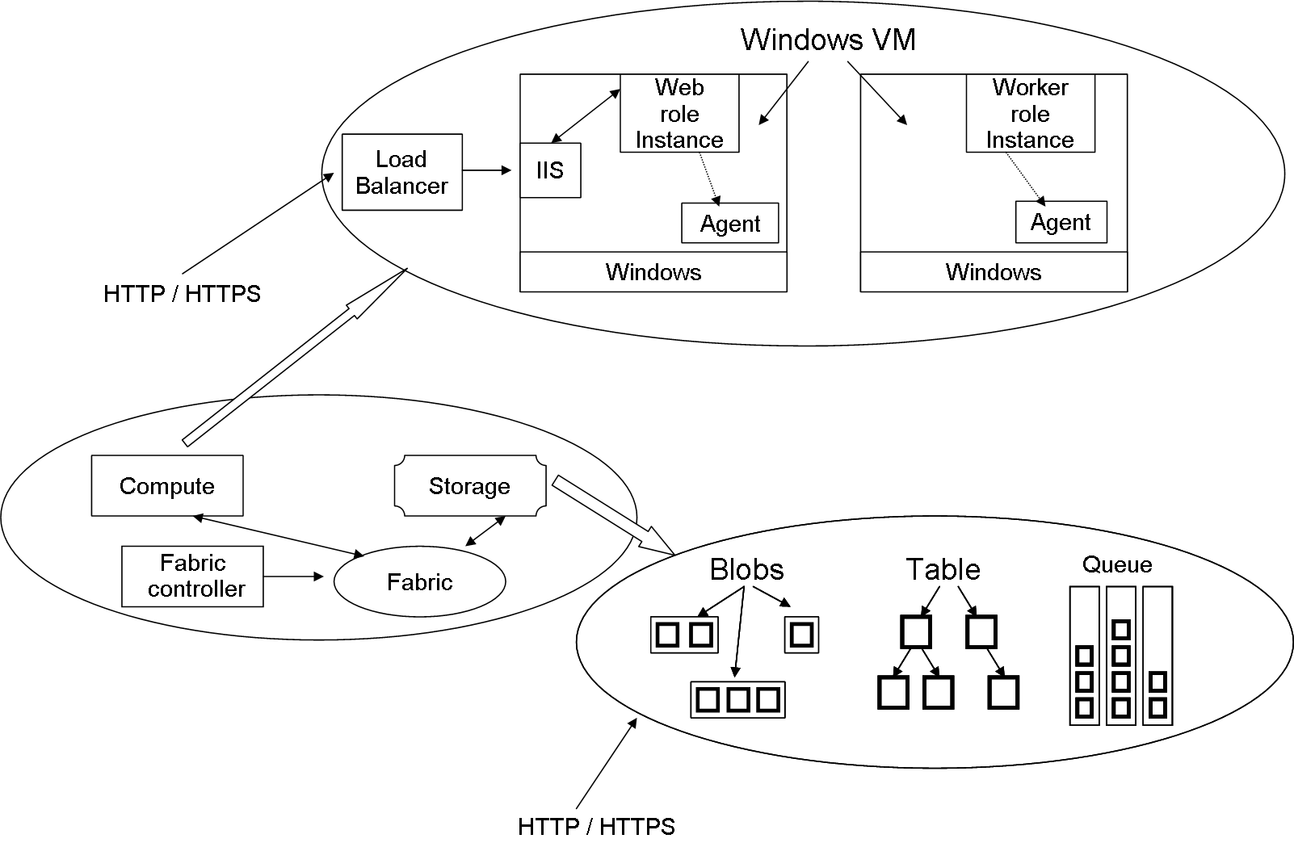

Figure 5: Windows Azure component architecture

IIS configured. They can be configured to run executable of users’ right. Worker role instance is more likely to function like a background job. Web role instances can be used to accept request from the users and then they can be processed by Worker role instances in a later point of time. For a compute intensive work many Worker role instances can run in parallel.

Loging and monitoring of Azure applications is made easy by provision of ap-plication wide log. a developer can collect performance related information like measure of CPU usage, store crash dumps in the storage. Azure doesn’t give the developer the freedom to use his/her own VM image for Windows Azure. The platform maintains its own Windows. Applications in Azure run only in user mode - no administrative access isn’t allowed here. So Windows Azure can update the operating system in each VM without any concern of affecting the applications running on it. This approach separates administrative work from the user domain.

*•* The Storage Service: Applications running in Azure uses storage of different types:

17

**Cloud Computing**

**–** Blobs: This is used for storing binary data in a simple hierarchy. Blobs can have associated metadata with them. A user account can have one or more containers and these containers have one or more blobs.

**–** Storage tables: Blobs provide mechanisms for unstructured data but for

|  |  |
| --- | --- |
| more structured purposes tables are more suitable. | These tables are |

nothing like tables in a traditional database. They are actually stored in a group of entities. These tables can be accessed by using ADO.NET Data Services. SQL is not preferable for scale out issues.

|  |  |
| --- | --- |
| **–** Queue : | This is not a structure like tables or blobs to store data but |

these queues are used to store messages about tasks to be performed by Worker role instance. These tasks are written by Web role instances on receiving request from clients. A Worker role instance waiting on that queue can read the message and perform the task it specifies.

All data in the Windows Azure storage is replicated three times for providing fault tolerance. Azure also keeps backups in geographically distributed data centers. Windows Azure storage can be accessed by any Windows Azure ap-plication as well as any application hosted at another cloud platform. All the blobs, tables, queues are named using URIs and can be accessed by HTTP methods calls.

Some applications have inherent need for relational databases. This is provided in the form of *SQL Azure*. This is build on Microsoft SQL Server. This data can be accessed via ADO.NET or by other Windows data access interfaces.

*•* The Fabric: All Windows Azure application and all of the data stored in Azure Storage live are physically happen inside some of the data centers handled by Microsoft. In the data centers the set of machines dedicated to Azure are organized into a fabric. These machines are managed by fabric controller. These are replicated in five to seven machines. These controllers are aware of every Windows Azure application running in that fabric and also owns Controllers all the resources like computers, switches, load balancers etc.

monitors, decides which resources to allocate to new applications looking at the configuration file with the application. They also monitor the running applications.

18

**Cloud Computing**

|  |  |
| --- | --- |
| **6** | **Cloud Computing Application in Indian con-** |

**text**

Today most of the studies in cloud computing is related to commercial benefits. But this idea can also be successfully applied to non-profit organizations and to the social benefit. In the developing countries like India Cloud computing can bring about a revolution in the field of low cost computing with greater efficiency, availability and reliability. Recently in these countries e-governance has started to flourish. Experts envisioned that utility based computing has a great future in e-governance. Cloud computing can also be applied to the development of rural life in India by building information hubs to help the concerned people with greater access to required information and enable them to share their experiences to build new knowledge bases.

**6.1**  **E-Governance**

E-Governance is an interface between Government and public or this can be an interface between two governments or between government and business organiza-tions [7]. Objectives are generally to improve efficiency and effectiveness to serve public demand and to save costs for online services. This requires Government to have the will to decentralize the responsibilities and processes and start to have faith on electronic and internet systems. E-government is a form of e-business in gover-nance and refers to the processes and structures needed to deliver electronic services to the public (citizens and businesses), collaborate with business partners and to conduct electronic transactions within an organizational entity. This E-Governance can be greatly improved by utility computing [8].

Impact of Technology in E-governance -

*•* 24/7 Service Model – Systems and services require high availability. Get the citizens feel that Government is always at their service.

*•* Need for Content – Web contents should be regularly updated and the infor-mation provided to the public should be sufficient. Respective departments should be responsible for providing the information.

*•* Human Resource – Building these IT skilled resources would need properly trained personals. This would make government to compete with other private organizations.

19

**Cloud Computing**

|  |
| --- |
| *•* Security – Sensitive Government data is to be highly secured. Policies are to be taken seriously maintained and designed.  *•* Privacy – Personal data should be given sufficient privacy. It can be a difficult issue if data is stored across different departments and computer systems. |

Recently Government of India have taken initiative and launched several projects to facilitate people with better mechanism of governance using IT as a tool. They have launched projects like Gyan Ganga, e-Gram [17] to leverage the strength of connectivity. Gyan Ganga is one of the initiatives of the Government of Gujrat to ensure wireless Internet connectivity to 18000 villages in Gujrat. This project is based on corDECT a technology based on Wireless Local Loop (WLL). Rural citizens are provided with facilities like browsing emails, Internet, land records, rural job opportunities, status of various government projects, information about local weather, soil and consult with experts to increase productivity in agriculture, to have answer to their queries about veterinary and health care. Gyan Ganga comes with other facilities with on-line registration of various applications, on-line public grievance form, information on Government projects etc.

Another Government of India initiative is E-Gram computerization of local Gram panchayats. This is also now implemented in the villages of Gujrat. This E-Gram provides the rural people services like birth and death certification, property assessment, tax-collection, accounts of gram panchayats etc.

Why traditional systems are not sufficient? For maintaining traditional sys-tems in e-government there are many more disadvantages.

*•* Application life cycle management – Applications are generally developed in evolutionary manner and changes should be consistent across all the depart-ments and up gradation should be performed when the system is functioning.

|  |
| --- |
| *•* Software licensing – Software should be licensed for each and every depart-ment terminal. This incurs a large amount of establishment cost.  *•* Scalability – Traditional centralized systems have inherent weakness towards the aspect of scalability.  *•* Security information is highly sensitive. So they should be highly secured. For the – This is the most crucial aspect for e-governance. Government |

traditional systems all the systems across all the departments should have sufficient security.

20

**Cloud Computing**

Most of these disadvantages are addressed by cloud computing [2].

*•* Scalability – Cloud computing by design supports scalability. The data cen-ters have enough computing and storage capacity to cope up with the spike

demand.

*•* Modifiable – Applications hosted in cloud can be modified internally without too much concern of the end users. Change in one place would reflect in all

the places inherently and it would be consistent.

*•* Data logging – This central facility can be very useful for locating any fault in the system. Logging can also be used for detecting unauthorized usage

checking or detecting compromization.

*•* Availability – Cloud services are well known for high availability. If any data center is down for any reason there is hot backup ready to work immediately.

Virtual machine migration is used to great extend in this situation to facilitate

load balancing in case of failure of some systems.

*•* Reliability – Replication and migration of instances across data centers make the reliability of the system very high in the cloud scenario.

*•* Physical disaster recovery – Backup policies can be very useful for physical disaster avoidance and this is inherent to the cloud system. Data is stored

in different physical location so that hot backup can be provided whenever

needed.

*•* Policy management – Polices can be managed in a centralized fashion. This is helpful for introducing Government policies readily unlike the present scenario.

*•* Legacy software – An already developed software can be moved to cloud with minor changes some times. So the Government doesn’t incur cost for develop-

ing applications which it already has.

|  |
| --- |
| *•* Pay model (Government) to reduce cost of deployment and control the usage.– Cloud providers’ pay-as-you-use model enables the customer  *•* Reduce power consumption – Adaptation of cloud reduces power consump-tion in different offices and usage of power is concentrated in the data center |

only. But also that is not the concern of the government as those data centers

are to be handled by the third party who provides cloud services.

21

**Cloud Computing**

Though it seems that cloud computing is indispensable for e-government but there are many issues related to Cloud Computing application -

*•* Security Concern – Government works are highly security sensitive and the policies sometimes must not be go into public. But in cloud computing scenario security is not properly implemented today. So this is a big concern.

*•* Policy Concern – Government has certain policies but the third party cloud provider may have contradicting policies.

*•* Lack of faith in networks – Many government departments don’t have that much trust in networks and internet. So they would not jump into accepting cloud computing.

**6.2**  **Rural development**

In the context of rural development cloud computing can also be used to success for its centralized storage and computing facility and utility based pay model. As per [3] 72.2% of total Indian population resides in rural areas. According to the survey conducted by “Hole in the Wall project” [11] computer literacy among boys and girls of age group 8-14 in rural area varies across the regions of India. It is 40-50% in most of the regions. So the computer literacy is not a concern in rural India and also in [11] it shown that learning rate is pretty high for computer literacy. Agriculture is India’s biggest employment source, accounting for 52% employment in India [4]. And agricultural sector contributes to 20% of country’s total GDP. So it is very important to make a serious attempt to develop rural India.

Rural development can be in the form of education, agriculture, health, cul-ture or in any other fields. Now a days most of the villages have some access to electricity and cellular phone. So there is technical feasibility of establishing com-puter systems. But the mentality of the people haven’t been changed that much and that’s why the spread of personal computer is not that much significant in the villages. We think this growth rate can be enhanced if the computing system is really cheap, easy to operate with minimum level of knowledge, without upfront commitment and more essentially if the system is helpful to enhance their life style. The main aim of the system is to make the people in rural areas to have access to recent technology and with the help of the computing system enhance their standard of living and also this would lead to a grater good of developing the nation.

Why not traditional web services?

22

**Cloud Computing**

|  |
| --- |
| *•* Availability – Many of the services should be available always like health etc. These availability issues are not that well handled by the traditional web |

services as they are handled typically by a single server and thus the server downtime is always there to happen.

*•* The villagers have to own a PC – To use traditional web services through in-ternet the villagers need to own a PC which would increase their investment. Then the issues of need for technical experts for software/hardware installa-tion and maintenance are needed. But naturally the number of such experts is very less in number in the remote village. Upgradation of software or hardware would be a problem both economically and technically.

With the help of cloud computing this can be made possible. We’ll now discuss the technological and economic advantages for using cloud.

*•* No upfront commitment – The villagers need not to invest too much to buy computing system and commit. But instead they can have very low cost terminals with basic functionality of I/O and have a network access.

*•* No maintenance issues – The users need not to be an expert for maintenance. This solves the unavailability of technical experts in the remote villages as the maintenance issues are handled by the cloud provider explicitly.

*•* Upgraded version of hardware and software – The users always use the up-graded version of software and hardware as maintained by the cloud provider. This reduces the cost of up gradation.

*•* On-demand resource allocation – The virtual resources can be extended as needed. If the user needs more resource then it is provided on demand basis.

*•* Utility computing model – The economic model used by the cloud is pay-as-you-use. This enables the users handle the cost they have to pay.

By using cloud computing model some improvement of the current system is possible to bring about social and as well as economic prospect in rural India.

*•* Share knowledge and build knowledge base – Most of the agriculture related issues are generally local and they can’t be solved by general expertise. So it happens many times that the so called experts are not the right person to answer the problems but instead the local farmers are better in understanding.

23

**Cloud Computing**

So in these situations better solution can be given by the local experts. If these local experts access a common space to share their knowledge then others eventually come to know about the solution. Thus a knowledge base can be build which would represent the issues in that local scenario. It is like building Wikipedia.

*•* Health and medical services – In the developing countries like India one of the concern of Rural health care is in spite of best intention from both the medical professionals and patients a practical challenge is faced for difficulties of communications among interested parties [15]. This issue can be solved using cloud computing in an appropriate way. Consultation among doctors around the world make sharing of knowledge possible and takes telemedicince to the next level, creating a network that goes beyond the one-to-one, patient-to-patient, patient-to-doctor or doctor-to-doctor interactions. In this way a patient suffering from a particular disease can be better treated by consulting with doctors within region and also outside who may have more experience with such a case.

*•* Education in remote areas – Education in rural areas can be enhanced with the help of distance education. Education can be provided in different lan-guages and with respect to different curriculum with the aid of e-learning components. Students can be encouraged to build their own multimedia pre-sentations. These can be hosted in the cloud. This type of approach encourage the students to concentrate more on learning and representing the material and also that would build the knowledge in the cloud for other students to refer. This is possible with the aid of cloud computing with greater reliability and availability.

*•* Government decision making – Looking at the common knowledge base the Government can have a fair knowledge of the local situation and take adoptive steps.

*•* Access to Information hub – Government can provide relevant information such as land revenue data, weather data, soil information etc. through these cloud services to the people concerned.

All these things are possible with right initiative. These may need customiz-ing the original cloud services. Some generally unpopular services like Desktop as a Service may make sense in these scenario which essentially tells about providing the users a virtual desktop environment. But deployment of cloud services in rural areas have some issues associated with it.

24

**Cloud Computing**

|  |
| --- |
| *•* The first and foremost issue for the deployment of internet based services in rural India is the availability of electricity and networks. Currently there are |

a number of initiatives underway to explore alternative to wired Internet, in-cluding WiFi, WiMax, satellite-based Internet connectivity. Such an effort is made by Midas Communication technologies and Indian Institute of Madras in the name of corDECT which is a wireless access system. It provides simul-taneously voice and 35-70kbps Internet access to wireless subscriber. Another effort is [19] where the authors modified traditional WiFi to make it efficiently work in long distance suitable in the context of rural area.

*•* Optimization due to data locality – Store the data where it is mostly used is known as the data locality. This is very helpful for optimization purpose. This can be done by establishing data centers in rural India. But the cost of power and bandwidth may not be cheap in many places. So for those places some efficiency and economic trade off should be obeyed.

India is now world’s 2nd fastest growing economy. As per World Bank survey, by this year the growth rate of India’s economy would be faster than currently fastest economy China. In India there is very large scope of applying IT in domestic level and that encouraged the cloud providers to establish cloud services in India. Today companies like Reliance, TATA, Zenith Computers, Wipro Technologies, Netmagic Solutions, and Reliance are providing cloud services in India successfully. These companies can grasp the huge market in the rural India as well as making social development.

**7**  **Conclusion**

Cloud computing is a newly developing paradigm of distributed computing. Vir-tualization in combination with utility computing model can make a difference in the IT industry and as well as in social perspective. Though cloud computing is still in its infancy but its clearly gaining momentum. Organizations like Google, Yahoo, Amazon are already providing cloud services. The products like Google App-Engine, Amazon EC2, Windows Azure are capturing the market with their ease of use, availability aspects and utility computing model. Users don’t have to be worried about the hinges of distributed programming as they are taken care of by the cloud providers. They can devote more on their own domain work rather than these administrative works. Business organizations are also showing increasing in-terest to indulge themselves into using cloud services. There are many open research

25

**Cloud Computing**

issues in this domain like security aspect in the cloud, virtual machine migration, dealing with large data for analysis purposes etc. In developing counties like India cloud computing can be applied in the e-governance and rural development with great success. Although as we have seen there are some crucial issues to be solved to successfully deploy cloud computing for these social purposes. But they can be addressed by detailed study in the subject.

**References**

[1] Google app engine. http://code.google.com/appengine/.

[2] Cloud computing for e-governance. 2010. Available online (13 pages).

White paper, IIIT-Hyderabad, January

[3] Demographics of india. http://en.wikipedia.org/wiki/Demographics_of_ India, April 2010.

[4] Economy of india. April 2010.

http://en.wikipedia.org/wiki/Economy_of_India,

[5] Michael Armbrust, Armando Fox, Rean Griffith, Anthony D. Joseph, Randy H. Katz, Andrew Konwinski, Gunho Lee, David A. Patterson, Ariel Rabkin, Ion Stoica, and Matei Zaharia. Above the clouds: A berkeley view of cloud com-puting. Technical Report UCB/EECS-2009-28, EECS Department, University of California, Berkeley, Feb 2009.

[6] F.M. Aymerich, G. Fenu, and S. Surcis. An approach to a cloud comput- ing network. *Applications of Digital Information and Web Technologies, 2008.*  *ICADIWT 2008.*, pages 113 –118, August 2008.

[7] M. Backus. E-governance in Developing Countries. *IICD Research Brief*, 1, 2001.

[8] Jaijit Bhattacharya and Sushant Vashistha. *Utility computing-based framework*  *for e-governance*, pages 303–309. ACM, New York, NY, USA, 2008.

[9] D. Chappell. Introducing windows azure. http://go.microsoft.com/, De- cember 2009.

26

**Cloud Computing**

[10] Vidyanand Choudhary. Software as a service: Implications for investment in software development. In *HICSS ’07: Proceedings of the 40th Annual Hawaii In-ternational Conference on System Sciences*, page 209a, Washington, DC, USA, 2007. IEEE Computer Society.

[11] Ritu Dangwal. *Public Computing, Computer Literacy and Educational Out-come: Children and Computers in Rural India*, pages 59–66. IOS Press, Ams-terdam, The Netherlands, 2005.

[12] I. Foster, Yong Zhao, I. Raicu, and S. Lu. Cloud computing and grid com-puting 360-degree compared. Technical report. Grid Computing Environments Workshop, 2008.

[13] Simson L. Garfinkel. An evaluation of amazon’s grid computing services: Ec2, s3 and sqs. Technical report, 2007.

[14] S.L. Garfinkel. Commodity grid computing with amazon’s S3 and EC2. https://www.usenix.org/publications/login/2007-02/openpdfs/ garfinkel.pdf, 2007.

[15] K.I. Juster. Cloud Computing Can Close the Development Gap. http://www. salesforce.com/assets/pdf/misc/IT-development-paper.pdf.

[16] Leonard Kleinrock. An internet vision: the invisible global infrastructure. *Ad*  *Hoc Networks*, 1(1):3 – 11, 2003.

[17] P. Kokil. SAP-LAP Analysis: Gyan Ganga, E-Gram and Communication Infor-mation Centers (CIC). http://www.iceg.net/2007/books/3/29_290_3.pdf.

[18] Ralf L¨ammel. Google’s mapreduce programming model – revisited. *Sci. Com-* *put. Program.*, 70(1):1–30, 2008.

[19] R. Patra, S. Nedevschi, S. Surana, A. Sheth, L. Subramanian, and E. Brewer. WiLDNet: Design and implementation of high performance wifi based long distance networks. In *USENIX NSDI*, pages 87–100, 2007.

[20] Bhaskar Prasad Rimal, Eunmi Choi, and Ian Lumb. A taxonomy and survey of cloud computing systems. *Networked Computing and Advanced Information Management, International Conference on*, 0:44–51, 2009.

[21] J.E. Smith and R. Nair. An overview of virtual machine architectures. pages 1–20, October 2001. http://www.ece.wisc.edu/~jes/902/papers/intro.pdf.

27

**Cloud Computing**

|  |  |  |
| --- | --- | --- |
| [22] Persistent Systems. | Google app engine. | http://www.persistentsys.com/ |

newpspl/pdf/CMS_1741820566_Google%20Apps%20Engine_WP_010909.pdf, 2009.

28